ROYS A KAREEM
Specialist I – UX Design
Mobile: +91 9846666988
Email: roysak@gmail.com
LinkedIn: https://in.linkedin.com/in/roysak
Website: https://roysak.in
Digital product designer, with 15+ years of experience bridging user-centric design and technical execution. Adept at utilizing AI coding agents to accelerate rapid prototyping, mockups, and front-end development. I specialized in UX design, fluent in HTML/CSS, and proficient in JavaScript, with practical experience in modern frameworks like Angular, React, and TypeScript. Holistic problem solver skilled at navigating multiple layers of application development to deliver seamless, scalable, and intuitive digital experiences.

CORE COMPETENCIES
- AI-Driven Design & Development, leveraging AI coding agents to significantly accelerate rapid prototyping, mock-ups, and front-end coding.
- Seasoned UX/UI & Front-End Professional specializing in bridging user-centric design with scalable technical execution.
- Expert in the end-to-end UX design lifecycle, delivering refined requirements, UX research, user flow, wireframes, mock-ups, and interactive prototypes.
- Proficient in modern web technologies, with fluency in HTML5, CSS3, and JavaScript, and practical experience in Angular, React, and TypeScript.
- Holistic problem solver skilled at navigating complex application layers, with strong analytical and troubleshooting capabilities.
- Skilled Visual Designer, adept at crafting custom iconography, design systems, and high-quality interfaces based on modern UX principles.

SKILLS
- UX/UI: UX Research, User flows, Wireframing, Prototyping, Design Systems, Interaction Design
- Tools: Figma, Adobe XD, GitHub Copilot, VS Code, AI Coding Agents (GitHub Copilot, Gemini, Claude), Prompt Engineering, AI-Assisted Development.
- Frontend: HTML5, CSS3, SCSS, JavaScript, TypeScript, Angular, React
- Accessibility: WCAG, Responsive Design

EXPERIENCE
UST
December 2016 – Present
Role: Specialist I – UX Design
Account – SmartOps
(September 2021 - Present)
Role – Specialist I – UX Design
Designed and developed core applications within SmartOps, including Automation Story (a drag-and-drop workflow builder), SmartGenie (an AI agent marketplace), and Dashboard Builder (interactive drill-down widgets), DataHub.
- Created wireframes, prototypes, and high-fidelity mockups to communicate design concepts, leveraging a hybrid approach of AI tools and manual refinement for optimal efficiency.
- Engineered a custom Theme Builder for PrimeNG components utilizing Angular and GitHub Copilot, significantly streamlining UI customization.
- Established and managed the overarching design system and style guide, ensuring visual consistency and UI standardization across all SmartOps applications.
- Partnered with cross-functional engineering teams to provide front-end development assistance and ensure accurate, scalable implementation of new features.
Key Responsibilities:
- Designed and developed concepts and interactive prototypes for new applications and feature enhancements.
- Translated UI/UX designs into responsive, high-quality front-end code using HTML, SCSS, and Angular.
- Collaborated with development teams to support implementation, debugging, and performance optimization.
- Assisted in end-to-end development activities, ensuring alignment with functional and design requirements.
Tools / Technologies Used:
Figma, HTML5, SCSS, Angular, GitHub Copilot, Claude, Gemini.
Account – Xerox
(September 2020 – August 2021)
Role – UI Designer/Developer
Worked on Xtract Web, an internal enterprise web application used by Xerox to support business operations.
Key Responsibilities:
- Designed concepts and created interactive prototypes for new features and enhancements.
- Converted UI/UX designs into responsive web interfaces using HTML, SCSS, and JavaScript.
- Assisted in front-end development, including implementation, debugging, and performance improvements.
- Collaborated with cross-functional teams to ensure seamless feature integration and delivery.
Tools / Technologies Used:
XD, HTML5, SCSS, JavaScript. Blazor (C#)

Product – CrystalBall
(April 2020 – August 2020)
Role – UI Designer / Developer
CrystalBall is a context sensitive intelligent mechanism to push / collate up-to-date information about our customer landscape, market intelligence, value-added services, products & platforms, and other offerings including alliances & partner service, which will equip our client facing teams to provide a best-in-class & faster response at every customer touch point.
Key Responsibilities:
- Designed UI assets include logos, icons, wireframes, mockups, and interactive prototypes.
- Contributed to front-end application development using Angular, supporting feature implementation and enhancements.
- Collaborated with design and development teams to ensure consistency between UI design and application functionality.
Tools / Technologies Used:
XD, Photoshop, Illustrator, HTML5, CSS3, Angular, TypeScript, JavaScript.

Product – Revin
(June 2020 – August 2020)
Role – UI Designer
Revin was an internal project (concept).
Key Responsibilities:
- UI Design which includes Logo, Icons, Wireframe, Mockups and Prototype.
Tools Used:
XD, Photoshop, Illustrator.

Account – Tickets.com
(December 2016 – March 2020)
Role – UI Designer / Developer
MPV (My ProVenue) is a web-based ticketing application that enables users to purchase tickets for various events. The platform consists of two primary products: ProVenue and ProVenueOnline.
ProVenue is the core ticketing system responsible for managing ticket inventory, including seat allocation and availability, venue information, delivery methods, and payment options.
ProVenueOnline is the front-end application that interacts with ProVenue via API calls to perform key ticketing operations such as sales, purchases, returns, exchanges, and replays.
Key Responsibilities:
- I started as a UI Designer, creating detailed venue maps, and later transitioned into a front-end development role.
- Contributed to improving accessibility standards by helping make web pages WCAG compliant.
- Supported front-end development using Angular, assisting in feature implementation and enhancements.
- Collaborated with cross-functional teams to ensure alignment between design, accessibility, and development.
Tools / Technologies Used:
Photoshop, Illustrator, HTML5, CSS3, Angular, TypeScript, JavaScript

Vtrio Solutions Pvt. Ltd.
December 2005 – November 2016
Role: UI Designer/ Developer
PROJECTS & TASKS
- Designed web pages, wireframes, mobile applications, high-fidelity mockups, and interactive prototypes.
- Developed and customized themes and UI skins across multiple platforms and frameworks.
- Worked with a diverse tech stack including WordPress, vBulletin, Magento, Shopify, jQuery, PHP, and mobile application technologies.
- Collaborated with development teams to ensure seamless integration of design and functionality across platforms.

CERTIFICATIONS

- Google UX Design (Google) 2023
- Claude Code in Action (Anthropic) 2026
- Enterprise Design Thinking Practitioner (IBM) 2023
- Creative Coding (Domestika) 2023

EDUCATION
BCom
MA College, Kothamangalam 2003-2005

UI SAMPLES

SmartOps Interfaces:
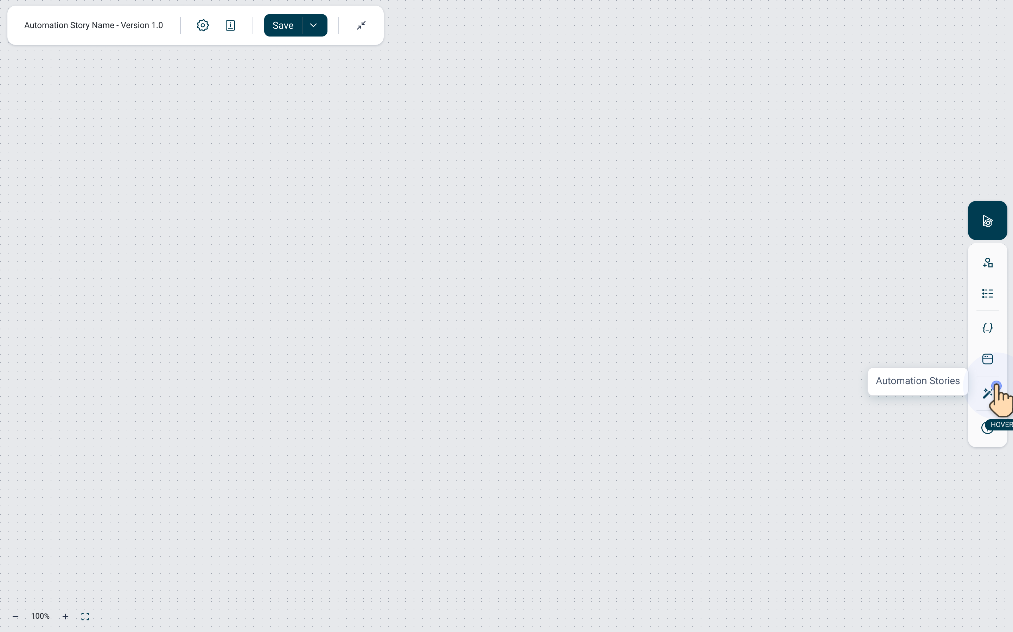 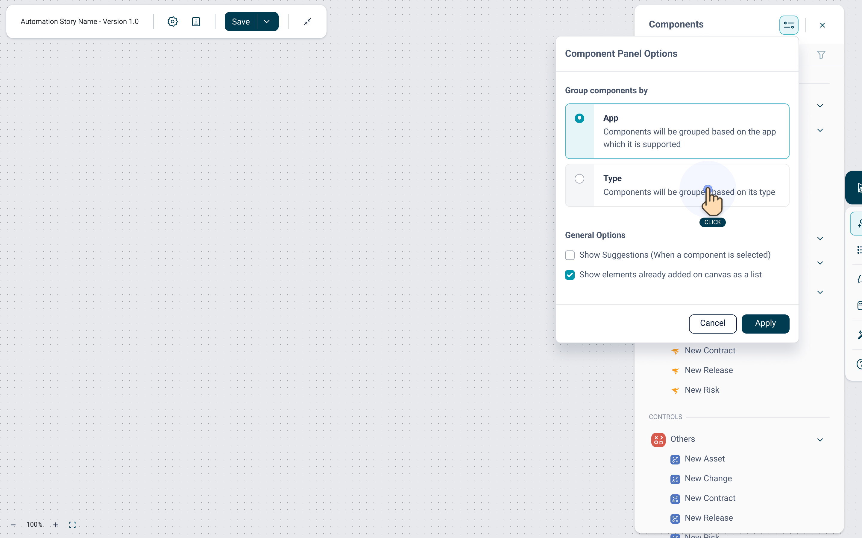
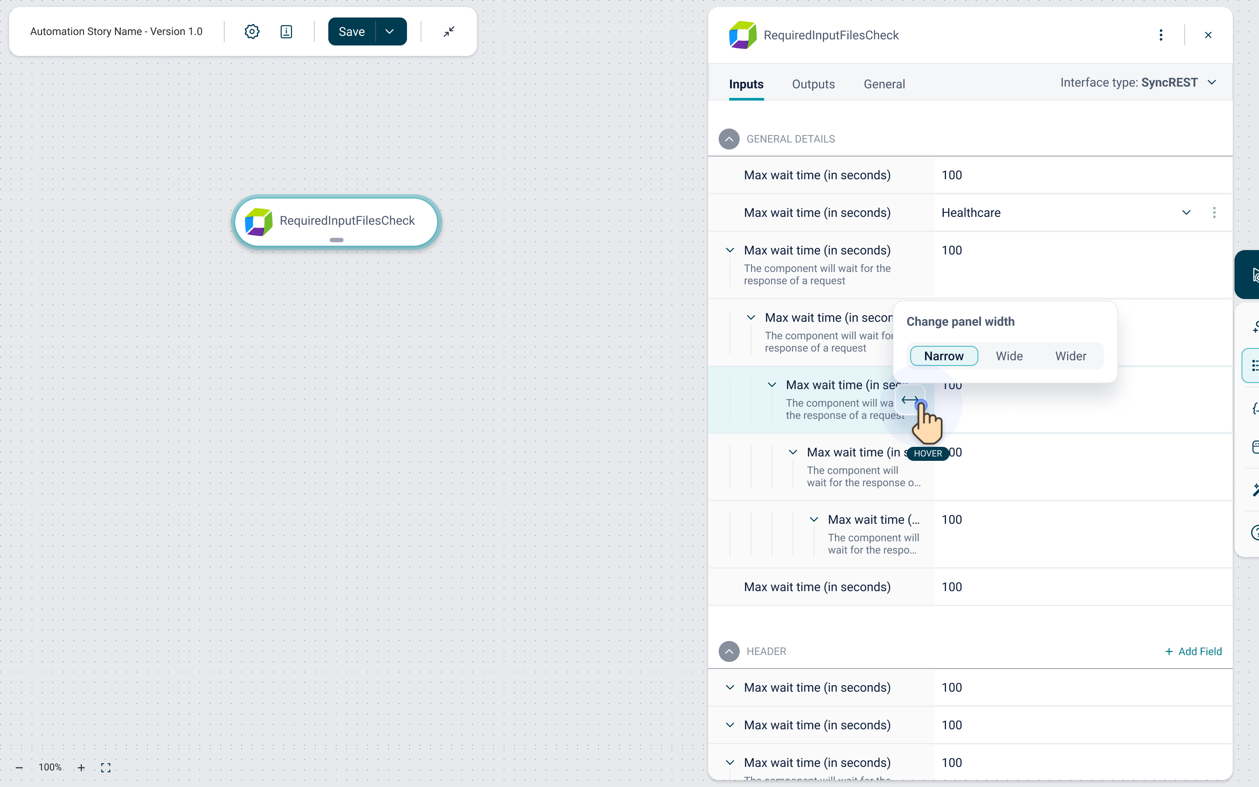
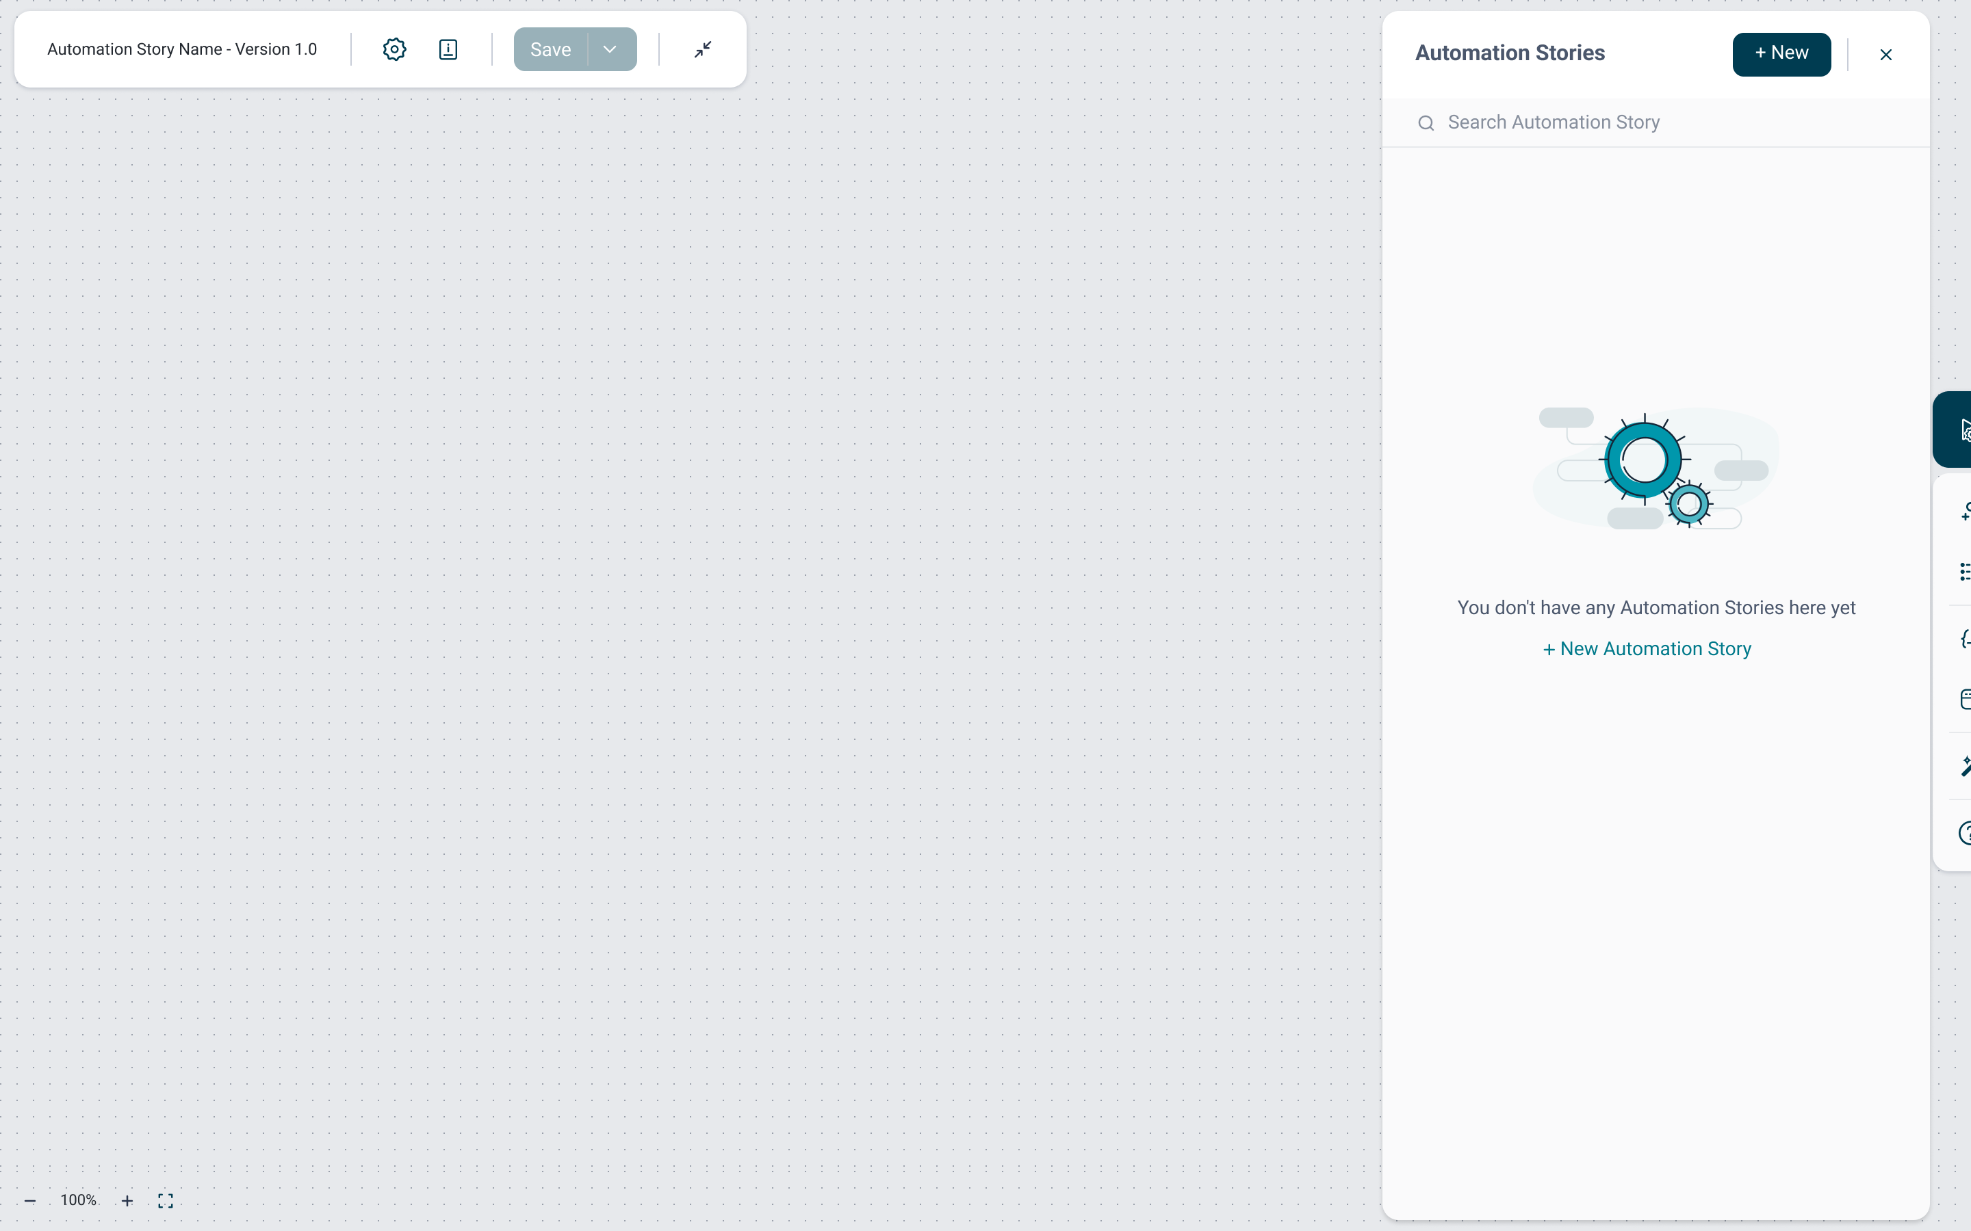 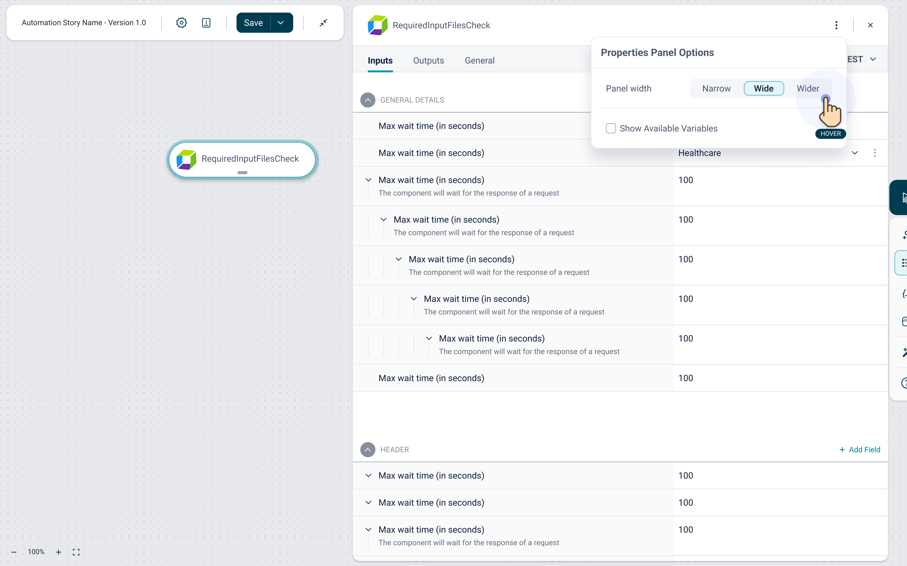
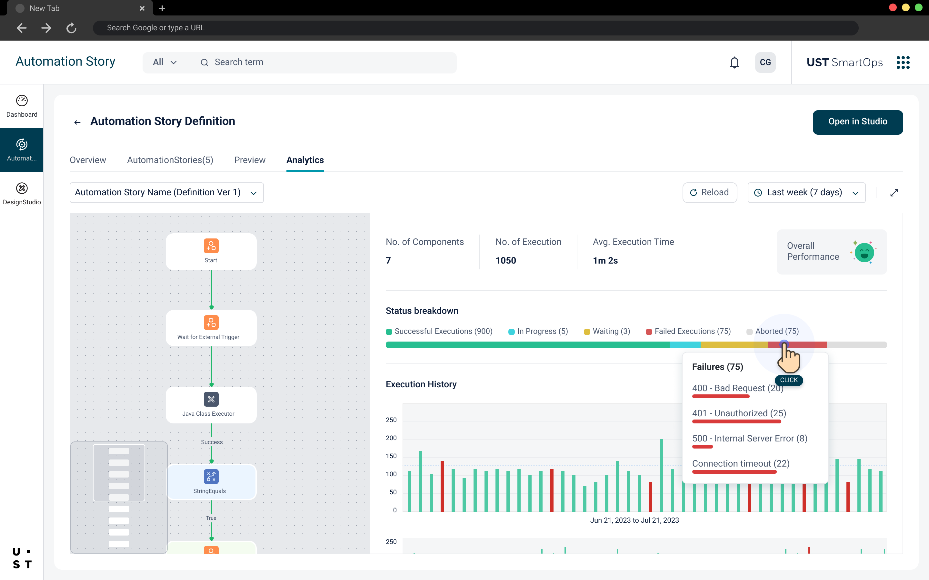 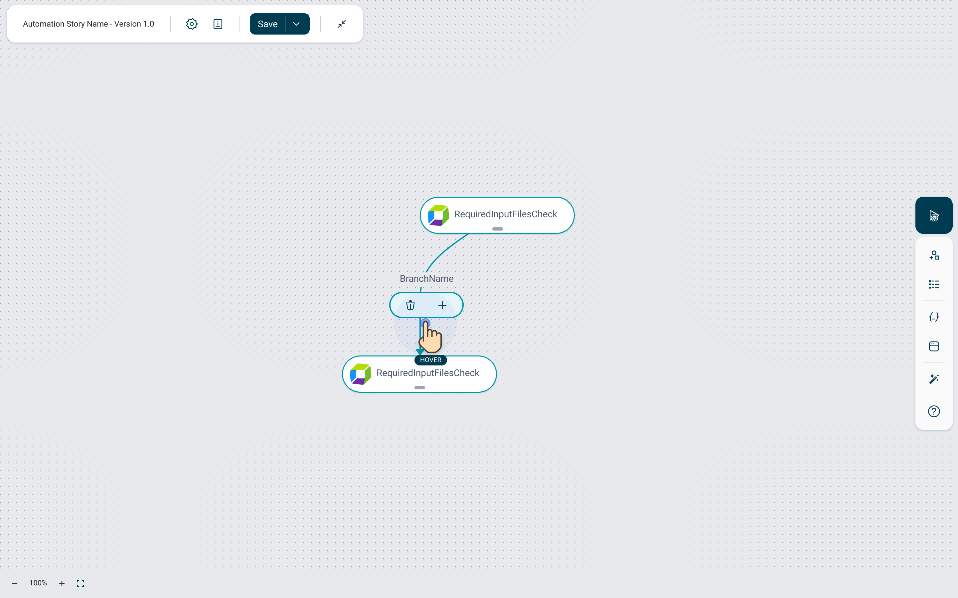
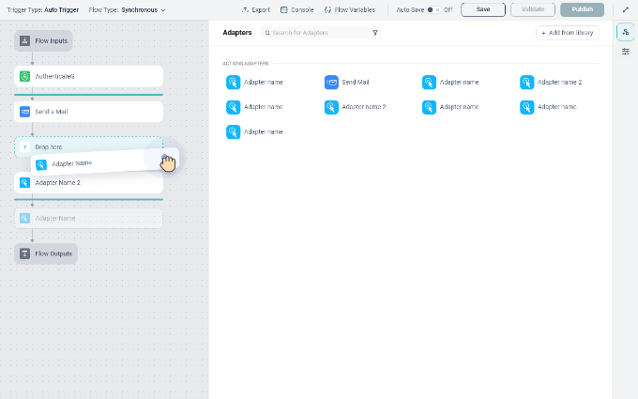 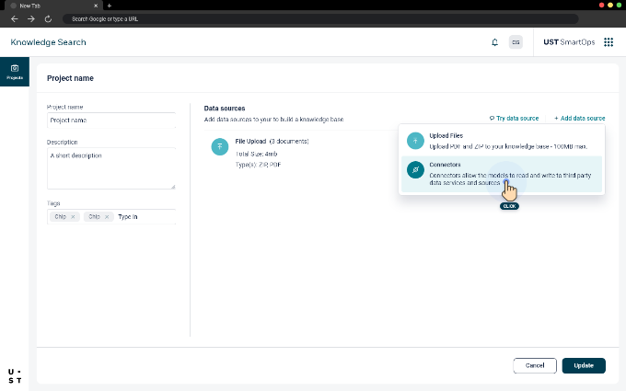
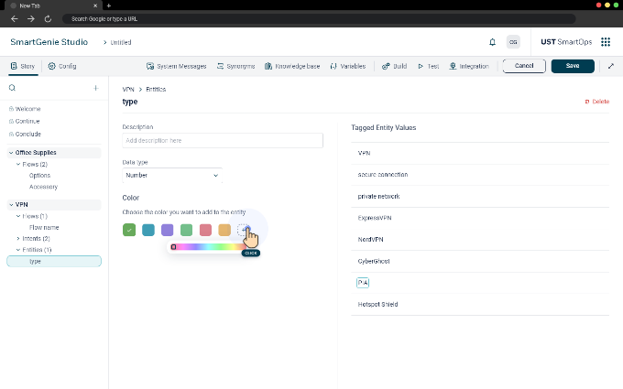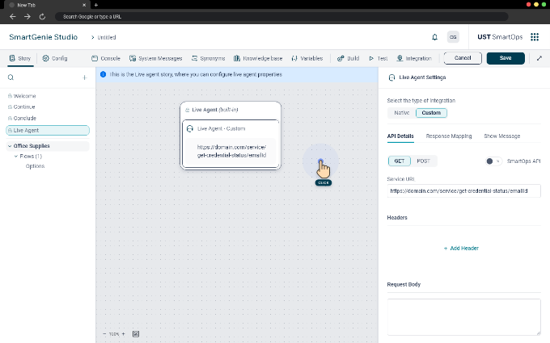

CrystalBall Interfaces:
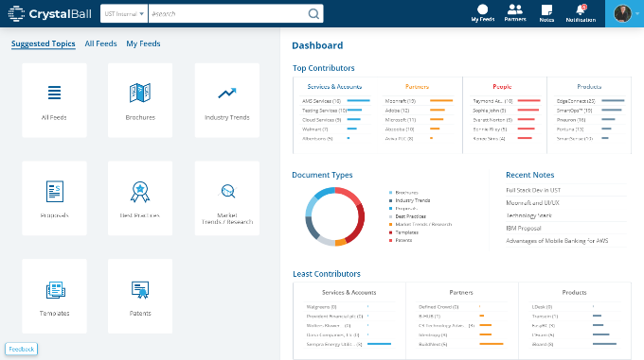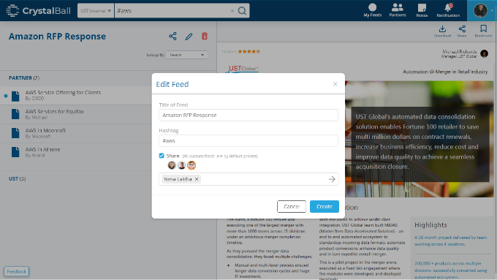

Revin Interfaces (Concept):
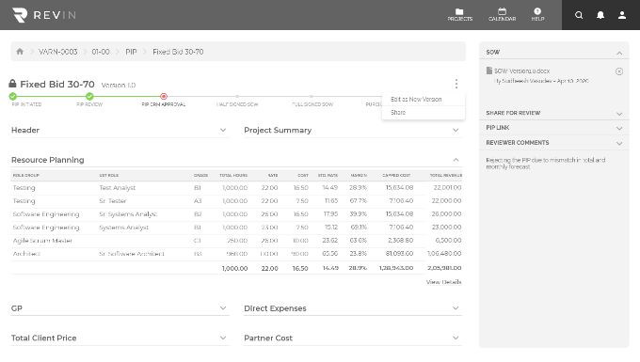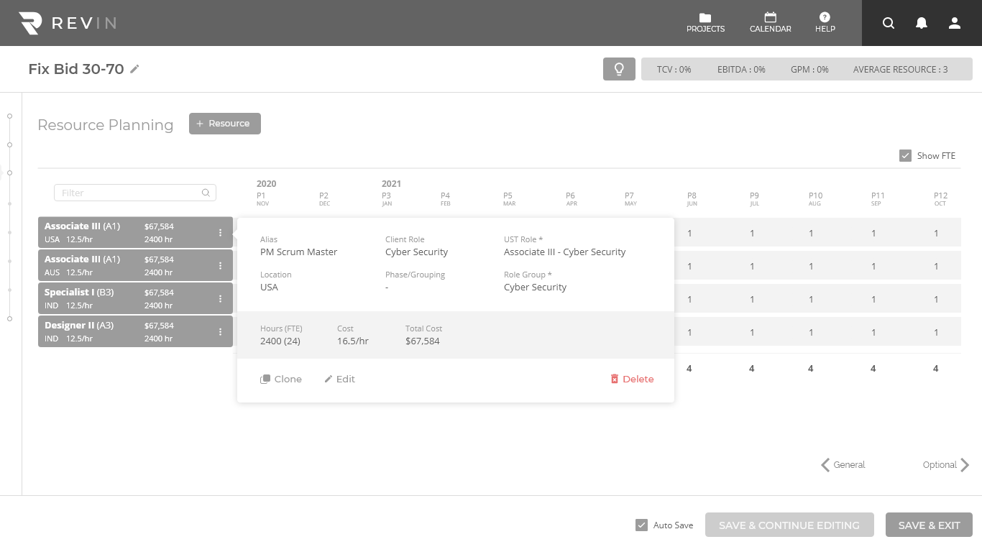

Tickets.com Interface Elements:
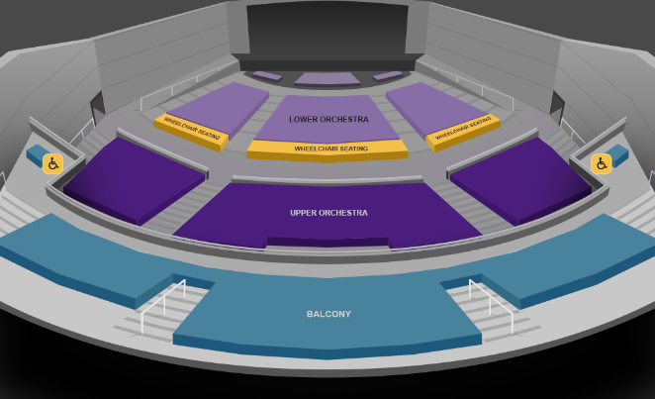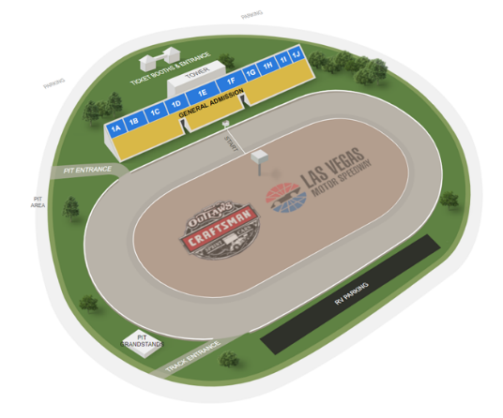

OTHER UI SAMPLES
All of the screen below are created for demo purpose. It doesn’t have any connection with any real product or pages.
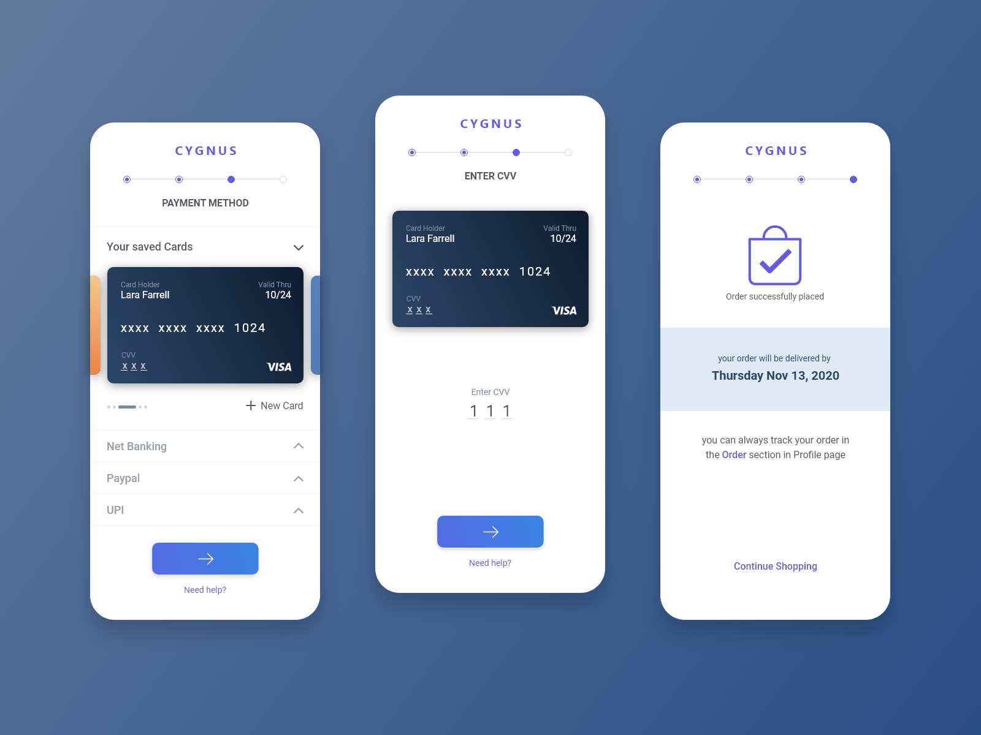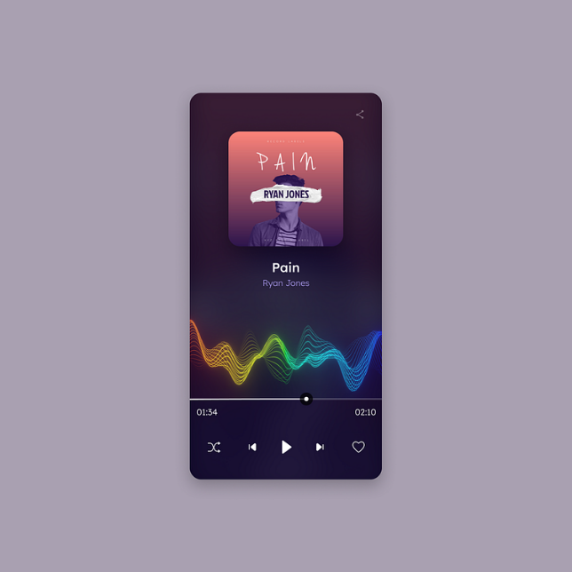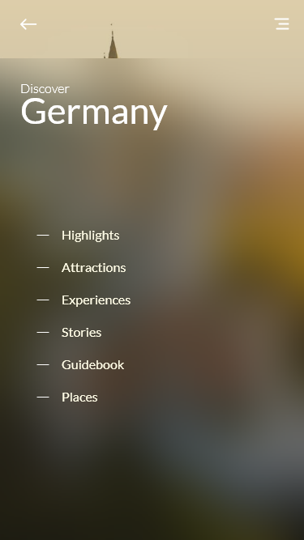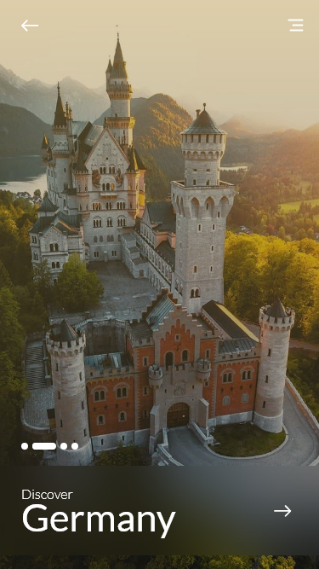

PERSONAL WORKS (Digital Paintings)

